**TypeScript DataTypes**

1. ***String***
2. ***Number***
3. ***Boolean***
4. ***Void***
5. ***Null***
6. ***Undefined***
7. ***Any***

| **BUILT-IN DATA TYPE** | **KEYWORD** | **DESCRIPTION** |
| --- | --- | --- |
| ***Number*** | ***number*** | ***It is used to represent both Integer as well as Floating-Point numbers*** |
| ***Boolean*** | ***boolean*** | ***Represents true and false*** |
| ***String*** | ***string*** | ***It is used to represent a sequence of characters*** |
| ***Void*** | ***void*** | ***Generally used on function return-types*** |
| ***Null*** | ***null*** | ***It is used when an object does not have any value*** |
| ***Undefined*** | ***undefined*** | ***Denotes value given to uninitialized variable*** |

***Any:: any-- If variable is declared with any data-type then any type of value can be assigned to that variable***

***app.component.ts***

import { Component } from '@angular/core';

@Component({

  selector: 'app-root',

  templateUrl: './app.component.html',

  styleUrls: ['./app.component.css']

})

export class AppComponent {

  title = 'Angular-App';

  role:string="Cricketer"

  name:string="virat";

  age:number=27;

  salary:number=1250000.0;

  isActive:boolean=true;

  color:string="white";

  type:any="Batsman";

  country: string;

  jersy:string=null;

  constructor(){

        console.log(`Role:${this.role}`);

        console.log(`Name:${this.name}`);

        console.log(`Age:${this.age}`);

        console.log(`Salary:${this.salary}`);

        console.log(`Active:${this.isActive}`);

        console.log(`Color:${this.color}`);

        console.log(`Type:${this.type}`);

        console.log(`Country:${this.country}`);

        console.log(`Jersy:${this.jersy}`);

 }

}

***app.component.html***

<!DOCTYPE html>

<html lang="en">

  <head>

    <meta charset="UTF-8" />

    <meta name="viewport" content="width=device-width, initial-scale=1.0" />

    <title>app</title>

  </head>

  <body>

    <h1>Welcome to Angular</h1>

    <ul>

      <li>Name::{{ name }}</li>

      <li>Age::{{ age }}</li>

      <li>Role::{{ role }}</li>

      <li>Active::{{ isActive }}</li>

      <li>Salary::{{ salary }}</li>

      <li>Color::{{ color }}</li>

      <li>Type::{{ type }}</li>

    </ul>

  </body>

</html>

***app.component.css***

body{

    background-color: lightcyan;

    height: 100%;

    width: 100%;

}

h1{

    text-align: center;

}

ul{

   font-size: 20px;

   font-weight: bold;

}

***Browser output***

***Console***

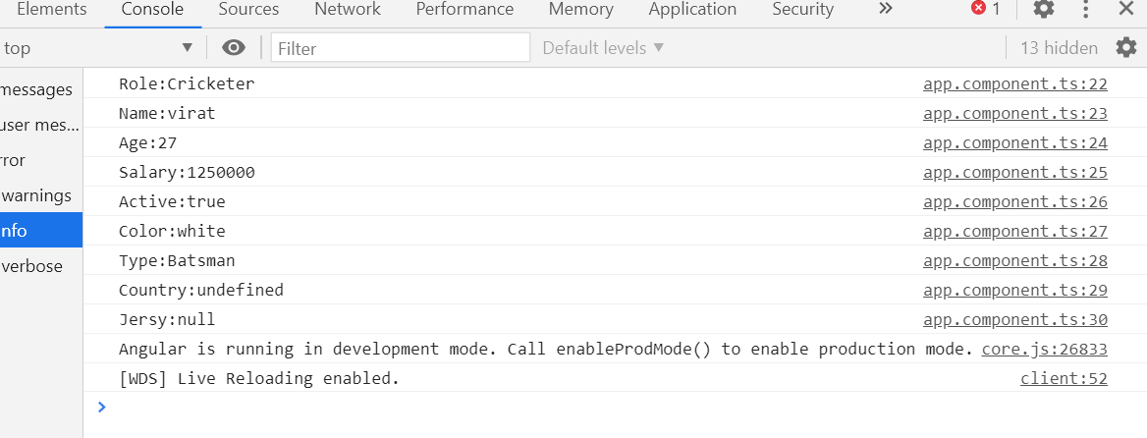

***Execution Flow***



